**Rounded shoulder**

**Causes**

* Musculoskeletal Compensations. Postural imbalances anywhere in the body can cause rounded shoulder.
* Environmental Factors.
* Exercise/Activity Choices.
* Psychological Stressors.
* Exercise and activity choices can also contribute to rounded shoulders. Prolonged periods of spine flexion, such as is required for bike riding and/or spinning, martial arts, freestyle swimming, and hobbies like knitting and gardening, all can cause rounded shoulders.
* Kyphosis.

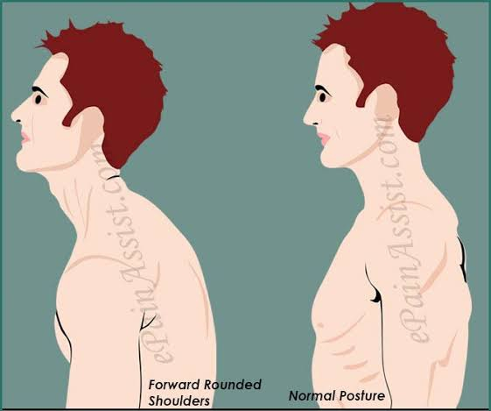

**Symptoms**

Rounded shoulders can manifest as a variety of symptoms.

**Pain**

Rounded shoulders are usually accompanied by overarching of both the lower back and neck. These positions of the spine can lead to pain, disc generation, and nerve compression.

**Limited Function**

The excessive flexion of the middle and upper back characteristic of rounded shoulders limits shoulder function, which can make activities like raising your arms to wash your hair, putting dishes in an overhead cupboard, or pulling on a sweatshirt difficult.

**Poor Health and Disease**

Rounded shoulders can affect respiration, which in turn, can restrict blood supply to internal organs. The downward movement of the diaphragm as it contracts helps massage the liver and bring blood supply to other vital organs. Hence, the disruptive nature of rounded shoulders on respiration can lead to any number of intestinal problems and/or disease.

**Increased Mental Stress**

When the body assumes a rounded shoulder posture, it is interpreted by the nervous system as stress. Over time this increased activity in the “stress areas” of the brain causes fatigue, resulting in the body (and brain) no longer being able to effectively cope.

**Rounded shoulders can affect respiration, which in turn, can restrict blood supply to internal organs.**

**Treatment**

**5 best exercise for rounded shoulder**

1. **Doorway stretch.**

[**https://youtu.be/rT7rgXQtDcI**](https://youtu.be/rT7rgXQtDcI)

1. **Trigger point release for chest muscle.**

[**https://youtu.be/k4au-gaKH5M**](https://youtu.be/k4au-gaKH5M)

1. **Wall slides.**

[**https://youtu.be/YIvNRUJp7_E**](https://youtu.be/YIvNRUJp7_E)

1. **Band pull Aparts.**

[**https://youtu.be/osRimvxXlKQ**](https://youtu.be/osRimvxXlKQ)

1. **Thoracic spine foam rolling.**

**https://youtu.be/cqd2USvPuCA**

[**https://youtu.be/_HK_Kf-4wxU**](https://youtu.be/_HK_Kf-4wxU)

[**https://youtu.be/SYr6lbx68n8**](https://youtu.be/SYr6lbx68n8)